# Project Specification

## Encoder GUI

## Endeavos Innovations

## Revision 1.0

## 7/2/2024

## Introduction

This project aims to capture, analyze, and display position and time data from an encoder via an intuitive GUI, featuring real-time charts and graphs

## Objective

The objective of the Encoder GUI project is to develop a comprehensive system for capturing, analyzing, and presenting position and time data from an encoder. This includes creating an intuitive graphical user interface (GUI) for user interaction, real-time visualization through charts and graphs, and data export capabilities. Initially implemented with LabVIEW for AVR microcontroller data visualization, the project aims to migrate to cross-platform frameworks like QT or wxWidgets to enhance versatility and usability in educational settings. The primary goal is to deliver a reliable educational tool that enriches learning experiences through clear and engaging data presentations. The project must be ready by August 1, 2024.

## System Overview

The overall system consists of a custom-built 3D printed encoder connected to an AVR microcontroller. The microcontroller transmits position and delta T data via USART, both on a regular timer basis and whenever an encoder interrupt is triggered. On the computer side, the data is received through USB and processed for further analysis and visualization.

## Brief Description of Operation

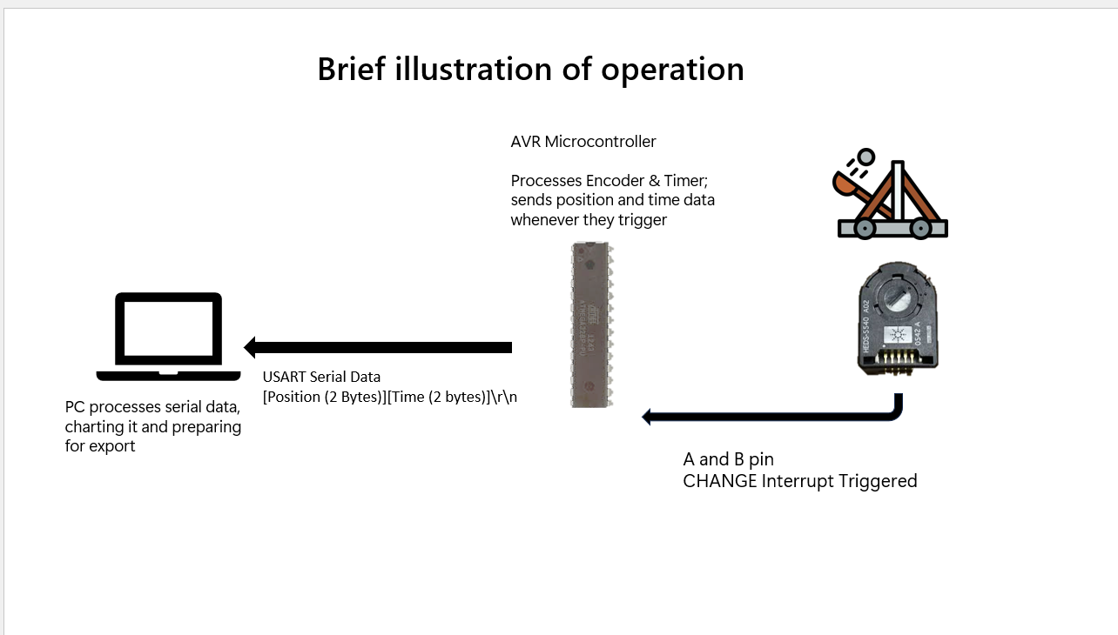

## Hardware

AVAGO Rotary Encoder

## Firmware (AVR Code)

## Input/Output List

## Software

## Acquisition Analysis

## Presentation

### User Interface

Below is a prototype of the UI. As shown, there is functionality for connection, toggling logging, resetting data, adjusting the frequency of data collection, and exporting on the right. On the left we have a pane to toggle between the real time chart, and the full chart data.

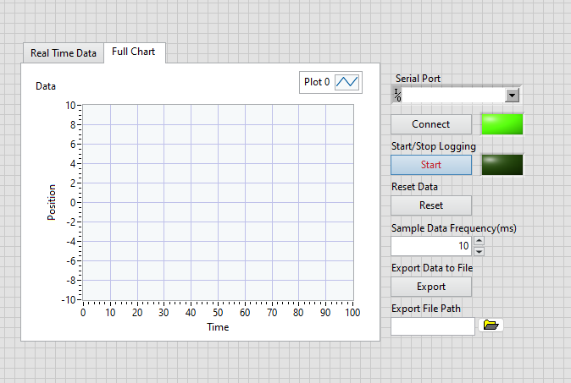

### Data Files

## Connectivity

## Priority Matrix Test Methodology Appendix A: Glossary Appendix B: Input/Output Channel List Appendix C: Sample Report Appendix D: Product Specifications